**Cat Adoption Packet**

Prince William County Animal Services Center

14807 Bristow Road

Manassas, VA 20112

[(703) 792-6465](tel:(703)%20792-6465)

[animalservices@pwcgov.org](mailto:animalservices@pwcgov.org)

**Congratulations**

**on Adopting Your New Family Member!**

Thank you so much for adopting from the Prince William County Animal Services Center and providing a loving home to a deserving pet. Your decision not only changes the life of your new furry friend but also helps us continue our mission of caring for animals in need and giving them a second chance at a forever home.

We want you to know that our support doesn't end here. If you ever have any questions or need assistance with your new pet, please don't hesitate to reach out to us. We are always here to help ensure a smooth transition and a happy, healthy future together.

**Happy Tails**

Nothing makes our volunteers and staff happier than hearing about successful adoption stories! We care deeply about our animal alumni and love to hear how they are doing in their new homes. If you would like to send an update on your newly adopted pet, please reach out to us at [animalservices@pwcgov.org](mailto:animalservices@pwcgov.org).

**Veterinary Care**:

A complimentary vet exam with the providers listed is included in your Adoption Contract. Please schedule an appointment as soon as possible to go over any questions you have about vaccines, parasite prevention, and other medical care that your new pet will need.

After adoption, animals can become stressed by the sudden change in their environment, as the sounds, sights, and smells are all different than what they have become familiar with. This change may also have a negative impact on their immune system, which can make them susceptible to respiratory infections and cause symptoms like sneezing, eye and/or nasal discharge, lack of appetite, or lethargy. Young kittens have fragile immune systems, in particular. If you see any of these symptoms, please contact a licensed veterinarian.



**Microchip**

Every cat adopted from the Prince William County Animal Services Center goes home with a microchip registered to SmartTag. The SmartTag microchip is a permanent pet ID with a one-time lifetime registration, that also comes with a visible metal SmartTag pet ID. To complete registration of your account, visit <https://www.IDtag.com/user/register> or call (201)-537-5644.

**Reminder:** if you ever move or any of your contact details change, be sure to update this information with the microchip provider.

**New Cat Supply Checklist**

Cat food (both dry and wet)

Bowls for food and water

Cat litter

Litter box and scooper

A soft cat bed

Brush and/or comb for grooming

Nail clippers

Cat carrier

Safety breakaway cat collar with ID tag

Scratching post – horizontal cardboard scratchers or tall vertical scratching posts

A variety of toys

**Cat Nutrition Information**

Depending on the age of your cat, they have been eating either of these dry foods pictured below while in our care.

Fromm Family

Kitten Gold or Adult Gold

½ cup daily

Wet food is also recommended to help your cat stay hydrated and we offer it daily from a variety of brands.

If you wish to change the brand of food that your cat eats, we recommend that you introduce it gradually by mixing the current food in with the new food. You may decide to feed your new cat any commercially available brand of cat food that is appropriate for their size and age. It is not uncommon to see some changes as their digestive system gets used to the new diet provided in your home. If digestive issues continue, we recommend consulting with a veterinarian.

It is essential to provide fresh water in a clean bowl daily and your cat should always have free access to the water. Some cats prefer to drink flowing water and may require a cat water fountain.

**Tips for Success and Helping Your New Cat Adjust**

Having the right setup is key to a smooth transition from our center to your home. Here are some tips to get you started:

* Many cats will be nervous when they first arrive in their new home. Set up a “safe room” for your new cat to start in until they become acclimated. Bathrooms and guest bedrooms work especially well for this. This room should have everything they need including food, water, a scratching post, toys, and a litter box.
* Interact with your new cat on their terms. Sit in their “safe room” with some space between you and the cat. Allow them to approach for pets and attention at their own pace. Treats can be used to entice your cat to interact with you and move things along more quickly.
* Once your cat is confidently exploring their safe room, you may decide to give them access to the rest of your home. Be sure to cat-proof your home to the best of your ability prior to letting them roam freely. For example, tie up any dangling cords on your window blinds, put candles and breakable objects out of reach, and remove any [toxic houseplants](https://www.aspca.org/pet-care/animal-poison-control/cats-plant-list).
* For the first few days, keep things relaxed and limit too much excitement. If possible, allow your cat to relax and get comfortable before inviting your friends and family over to meet him/her.

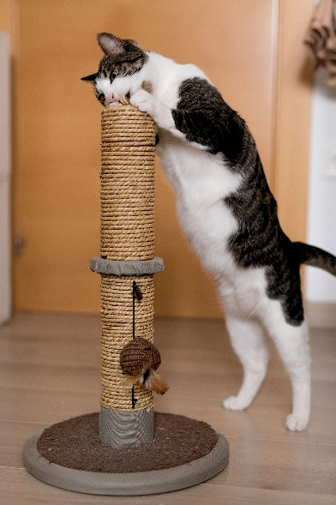

* Daily playtime using interactive toys, such as cat “wands” or feather toys, can help strengthen the bond between you and your cat. Play is also essential for keeping your cat happy and healthy. Always use toys during play, not your hands and feet.
* Scratching is a normal behavior for cats and can be directed to appropriate places, so be sure to provide plenty of cat-friendly scratching surfaces. Try to give your new cat the option of both horizontal cardboard scratchers and rope scratching posts to see what they prefer. Reward your cat with treats and/or praise for using their scratchers. You can also use catnip to attract your cat to the scratching posts.
* Make the carrier a happy place! Getting your cat used to going into a carrier will make traveling and vet visits so much easier. Simply set up the carrier with the door open and place a soft, comfy bed inside it. Place a treat inside the carrier once daily to encourage them to go in. You can play games with toys to get your cat to run in and out of the carrier. Once you notice your cat going into the carrier semi-regularly, you have successfully desensitized them.

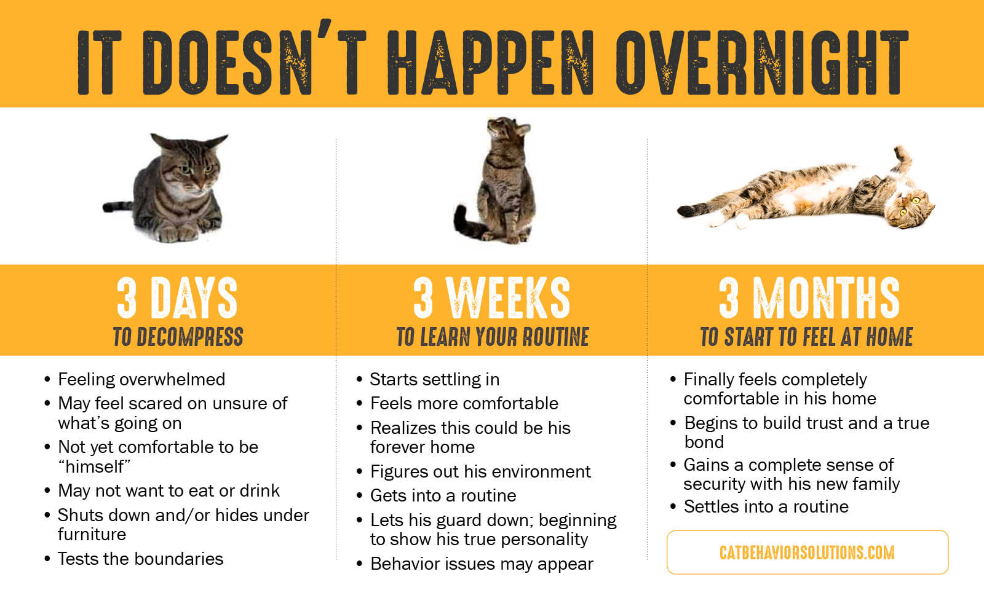

**Introducing Your New Cat to Other Cats**

* Take it slow. Successful introductions will take some time.Keep the cats separate. **It is not recommended to introduce the new addition to your resident cat(s) immediately upon arrival**. It is best to gradually introduce cats over the course of several days.
* While your new cat is adjusting in the “safe room” in your home, allow the cats to smell each other from underneath the door.
* Within a few days, exchange bedding or blankets to help the cats get familiar with each other’s scents. Place a treat on the bed or blanket to help them make a positive association with the other cat’s smell. You may also try feeding the cats on each side of the closed door to help them get acquainted.
* If there are no signs of aggression or significant stress from either cat, swap spaces. Allow your new cat to explore more of the home while your current resident cat spends time in the new cat’s “safe room.”
* 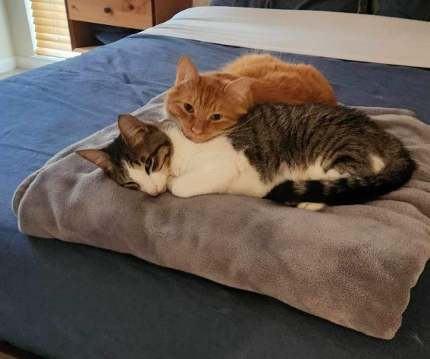Finally, if there are no signs of aggression or significant stress, allow the cats to meet each other **at their own pace** with **supervision**. Some cats may naturally accept a new companion without much trouble, but other cats may initially become upset and need more time to adjust. Do not be discouraged if they do not hit it off right away. If any of the cats become aggressive, give them some time apart and try again another day.
* Be careful not to discipline your cats for reacting poorly, as this is their way of communicating fear and stress. Instead, reward them with treats for the behavior that you want to see such as laying down in the same room together, sharing food, or allowing the other cat to receive your attention.
* Over time, many cats will work things out. If integration is not going well after several weeks, consider consulting with a behaviorist or veterinarian. A [Feliway](https://us.feliway.com/) pheromone diffuser may also assist with keeping the peace in multi-cat households.
* Reminder: Never leave animals unattended with each other unless you are sure that they are doing well together. This can take several weeks to do.

**Introducing Your New Cat to Your Dog**

* 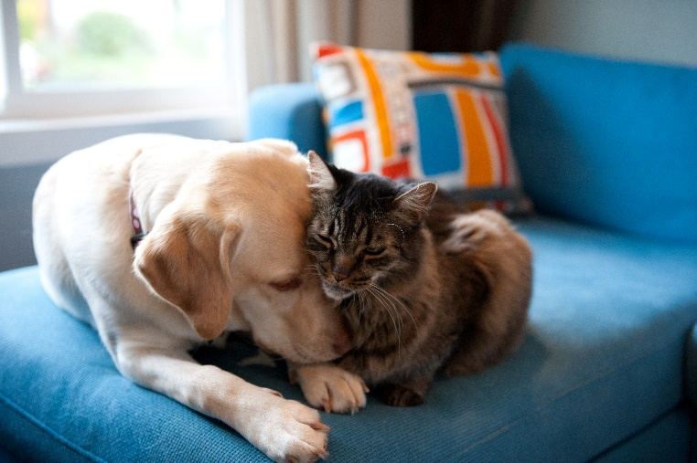**Take it slow.** If you have multiple dogs, introduce them to your cat one at a time to avoid overwhelming the cat.
* Working on basic obedience commands with your dog (such as sit, stay, come, and leave it) prior to introducing the animals will usually help introductions go more smoothly.
* Wait until your new cat is confidently exploring their “safe” room before proceeding with introductions to your dog.
* Feed your pets on opposite sides of a closed door. The goal is for them to associate a positive thing, such as food, with the smell of each other.
* Keep your dog on a leash during initial introductions to make sure that they will not try to chase or harm your new cat. Allow your cat to approach if he/she wishes.
* Ask your dog to sit and reward your dog for calm behavior around the cat. The first few sessions should be short and sweet.
* If your dog does well but your new cat is frightened or overwhelmed, allow the cat to retreat to their “safe room” until they are willing to try again. Make sure your cat always has access to dog-free sanctuary. Ideally, your home will be set up with multiple high areas, such as cat trees, shelves, or other furniture so that your cat can easily escape your dog, if needed.
* Repeat sessions daily.
* When the animals appear to be calm and comfortable around one another, allow them to be loose in the room together but keep your dog’s leash attached to their collar/harness and dragging on the floor. If your dog tries to chase your cat or otherwise misbehaves, you can step on or grab the leash to gain control of the situation and go back to earlier steps in the process.
* Even after successful interactions, continue to separate your pets when you are not able to supervise them until they have had significant time to get used to one another and you have not seen any concerning behavior.

**Litterbox Basics**

Most adopted cats are familiar with litter boxes and will naturally have an instinct to use them. It is important to show your new cat where the litterbox is located. **If your cat is not using their litter box, it is recommended to first rule out health problems by taking your cat to a veterinarian.** If this behavior is not due to a medical issue, here are some tips to help ensure that your cat uses their litter box:

* Clean litter box(es) regularly. Regularly cleaning out a litter box is good for your cat’s health and encourages them to continue using their litter box space. We recommend scooping the litter box at least once daily and emptying all litter once a week. After emptying the litterbox, clean it with a mild dish soap and replace the litter.
* Litterboxes should be easily accessible in a secluded quiet area in your home. Your cat should feel safe in this space to use the box regularly.
* If your cat likes to throw the litter out of the box, or overshoots the box, putting the litter box inside of another larger cardboard or high-sided storage box can help contain the mess.
* Provide multiple litter boxes in your home. Feline behaviorists have identified the ideal number of litterboxes as the number of cats plus one. If you live in a multi-level home, it may be beneficial to have a litterbox on each floor that your cat has access to.
* Cats prefer unscented, absorbent litter that clumps together. Clumping litter should not be used for kittens as there is a risk they will eat the particles.
* Many cats respond to stressful situations with litter box problems. Take notice of changes in the household, such as having less time for your pet or new additions to the family. Do not punish your cat for accidents, as this can make your cat even more anxious.

**Emergency Information:**

**Signs your pet may need immediate medical attention:**

* Straining to urinate
* Bleeding
* Difficulty breathing
* Pale gums
* Collapse
* Excessive vomiting
* Severe pain
* Sudden change in coordination
* Dragging back legs
* Multiple seizures
* Accidents/trauma

**Local emergency care for your pet:**

**MedVet Northern Virginia**

Open 24/7

703-361-8287

8614 Centreville Road,

Manassas, VA 20110

**If you suspect that your cat has consumed something toxic:**

Call your veterinarian or ASPCA Animal Poison Control Center Phone Number:

(888) 426-4435.

The ASPCA Animal Poison Control Center (APCC) is your best resource for any animal poison-related emergency, 24 hours a day, 365 days a year. A consultation fee may apply.

Visit <https://www.aspca.org/pet-care/animal-poison-control> for more information.

**Additional Resources and Helpful Links:**

* For more information on calming pheromone diffusers: <https://us.feliway.com/>
* For information on parasites from the Companion Animal Parasite Council: <https://www.petsandparasites.org/cat-owners/overview>
* Additional pet care information from the American Society for the Prevention of Cruelty to Animals (ASPCA):<https://www.aspca.org/pet-care/cat-care>