YARD WASTE COLLECTION AND APARTMENT RECYCLING CHANGES IN 2021
Friday, 1 Jan 2021

Public Works / Solid Waste Management

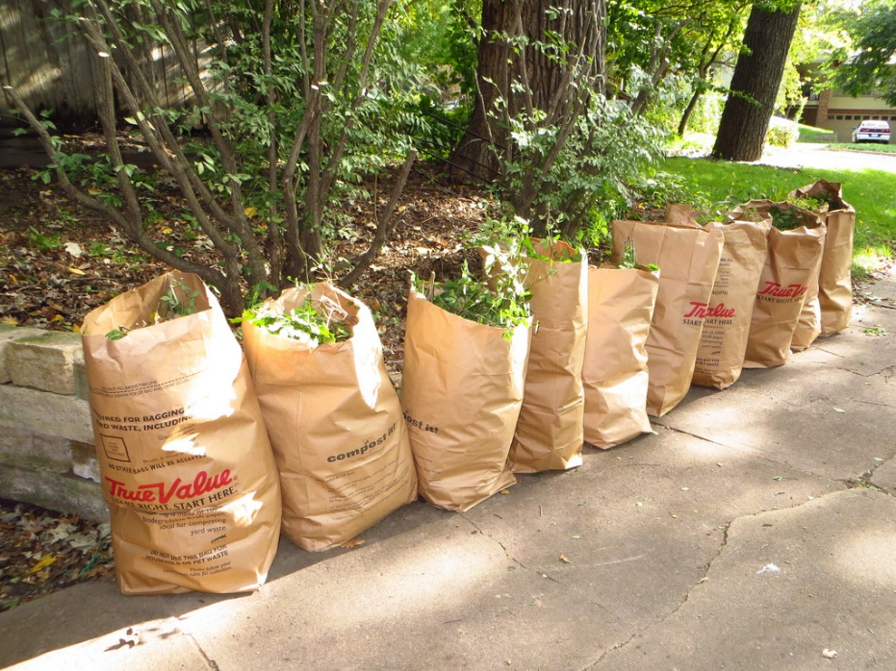
New Refuse Code Changes Effect the Entire Community
On Dec. 15, 2020, the Prince William Board of County Supervisors unanimously approved changes to Chapter 22 (Refuse) of the County Code. The key change is the mandatory separation and curbside collection of yard waste. The yard waste program is seasonal, running from March through December, but will not take effect until October 2021 to allow waste haulers time to equip and staff appropriately.
Residents, businesses, apartments, landscapers, etc. are required to arrange for a separate collection of yard waste, leaves and brush. Once the program starts, residents may place yard waste in biodegradable paper yard waste bags, or a personal container labeled for “yard waste.” The collected yard waste is converted into a soil amendment product at the recently expanded Balls Ford Road Compost Facility versus landfilled. In addition to yard waste collection, residents will also have access to Christmas tree recycling during the first two weeks of January each year.
Some of the benefits of a separate yard waste collection are:
• Diverts yard waste from the County landfill, which expands the landfill life by 10-15 years.
• Increases the County’s recycling rate.
• Improves the quality of the compost product.
• Provides more dependable collection of yard waste material.
The new curbside collection requirements are:
• Once a week refuse. • Once a week recycling.
• Once a week yard waste (March-December).
• Once a week Christmas tree pick up (first two weeks of January).
(Note: These are minimum standards. Trash and recycling collection companies may choose to provide additional collection.)
In 2021, the actual collection period is October 2021-December 2021, and Christmas tree collection is the first two weeks of January 2022. Yard waste collection will then resume in March 2022 for the full seasonal schedule.
There is also an important change for recycling by apartment tenants. Apartment management must provide sufficient single stream recycling collection bins for tenants. This will make apartment tenants’ recycling opportunities consistent with other residential households in the County. Property managers are now required to provide tenants and employees with information about how to participate in the recycling program.
Commercial and non-residential properties are also impacted by the recent code changes. While no changes were made to the existing requirement that all businesses and non-residential properties recycle the one material generated in the greatest quantities on an annual basis, business and nonresidential properties will have to adhere to the new requirements to separate and compost yard waste. In addition, the annual due date for annual recycling reports has moved to Oct. 15 instead of Feb. 15.
There are several other changes that will mainly affect businesses, but all the code changes were a result of County staff and representatives of the affected stakeholder groups meeting, discussing, and deliberating the issues and the necessary changes over many months. With these changes, the County realizes a goal from the 2004 Solid Waste Management Plan. “I think, these changes will significantly enhance the County’s overall waste reduction efforts. I am certain that the new Code will serve the County for years to come,” commented Scott MacDonald, solid waste division recycling manager. The new refuse code and a synopsis of the changes are available on the Solid Waste webpage.

