WHAT A WASTE--PW COUNTY LANDFILL WASTE COMPOSITION STUDY
Friday, 11 Jul 2014

Public Works / Solid Waste Management

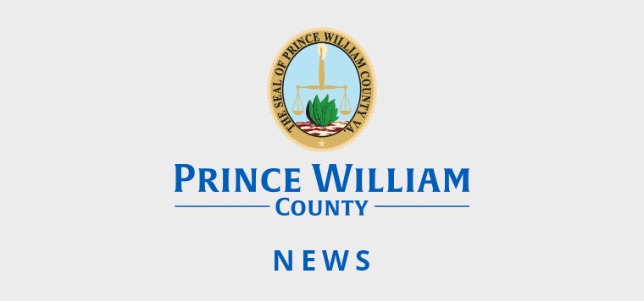
Fact: 70% of landfill waste is actually recyclable resources.
Check out the valuable resources residents, businesses and apartment complexes put into the trash and ultimately the Prince William County landfill. See the Waste Characterization Study conducted by SCS Engineers dated July 2014.

