NEW LAW PROTECTS SANITATION WORKERS
Friday, 17 Jun 2016

Public Works / Solid Waste Management

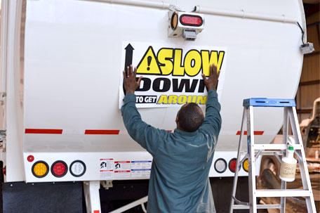
Proclamation and Law Celebrate and Protect Sanitation Workers
June 17 is National Garbage Man Day and on May 17 the Prince William Board of County Supervisors issued a proclamation that declares June 17 as National Garbage Man Day in Prince William County. Prince William citizens and the business community are encouraged to recognize these workers for their important work during the week of June 13, 2016.
The movement’s organizer encourages communities across the nation to take a moment and show appreciation for the men and women in the solid waste management industry and particularly, our trash collectors, for the life-saving service they provide on a daily basis.
In support, on June 16 and 17 the Prince William County Solid Waste Division will celebrate National Garbage Man Day at the Prince William County Landfill. All trash haulers that come to the facility will receive a word of thanks and some special safety tips because of the tremendous risks these workers are exposed to on the job. According to the U.S. Bureau of Labor Statistics, refuse and recyclable material collection is the fifth most dangerous job in the country, and transportation incidents are the cause of 40 percent of the injuries and fatalities.
After accepting the proclamation from Prince William County Board Chairman Corey Stewart, Tom Smith, Prince William County Solid Waste Division Chief, highlighted a new law that was signed by Virginia Governor Terry McAuliffe in 2015 to mitigate the dangers. The Slow Down to Get Around law says drivers must reduce their speed to at least 10 miles per hour below the posted speed limit and pass at least two feet to the left of any stationary vehicle that is collecting trash or recycling. Smith noted the impact these workers have on a safe environment, the 1000 tons of trash per day processed by haulers and County landfill staff and the fact that they all deserve to make it home safely.
The National Waste and Recycling Association has produced a Slow Down to Get Around PSA to bring attention to the new law and the tragic impact distracted or otherwise unsafe drivers can have on trash collection workers.
The Prince William County Solid Waste Division asks residents to imagine what our communities would be like without dependable collection and processing of unwanted, discarded waste and recyclables. Now, in addition to following the Slow Down to Get Around mandate, think of some ways you can celebrate the men and women that provide such important quality of life services to our families, businesses and communities.
To learn more about National Garbage Man Day, and how you can show your support, go to www.pwcgov.org/trashandrecycling or www.garbagemanday.org. Also send your celebration ideas and photos to PWCRecycles@pwcgov.org.

The Prince William County Solid Waste Division (SWD) provides solid waste management, recycling, composting and waste resource education to over 400,000 residents. The division employs more than 50 people and operates the only active Extraordinary Environmental Excellence (E4) rated landfill in Virginia, the highest level of certification awarded by Virginia Department of Environmental Quality’s (DEQ) Environmental Excellence Program (VEEP). In 2013, the SWD also earned the Governor’s Environmental Excellence Gold Medal Award for its Sustainability Program. The SWD is a part of the Prince William County Public Works Department, an accredited agency of the American Public Works Association.

