RECYCLING REPORT RESULTS FOR CALENDAR YEAR 2019
Wednesday, 1 Jul 2020

Public Works / Solid Waste Management

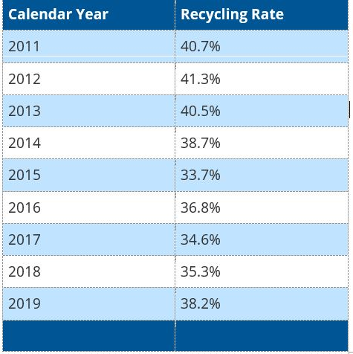
COUNTY RECYCLING RATE FOR 2019 IS 38.2%
Prince William County increased its recycling rate to 38.2 percent for 2019. This is almost a three percent increase from the 2018 rate. The Virginia Department of Environment Quality (DEQ) Prince William County confirmed this rate in September 2020.
The Commonwealth of Virginia requires each city, county, town or region to maintain a minimum recycling rate. Based upon the criteria established by the Commonwealth of Virginia, Prince William County exceeded its mandated 25 percent recycling rate again in 2019. The percentage increase is the highest the County has achieved since 2016.
Annual Recycling Rate
Calendar Year | Recycling Rate
2011 | 40.7%
2012 | 41.3%
2013 | 40.5%
2014 | 38.7%
2015 | 33.7%
2016 | 36.8%
2017 | 34.6%
2018 | 35.3%
2019 | 38.2%
2020 | TBD

