Changes in Recycling Impacting Local Community
Friday, 22 Feb 2019

Public Works / Solid Waste Management

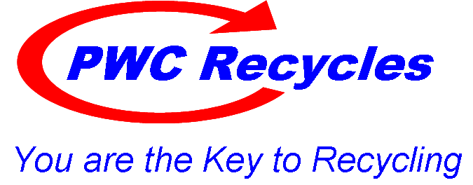
Significant changes in international recycling markets are trickling down to Prince William County. Countries that once bought material for recycling have tightened their rules and regulations, and those changes are starting to be felt locally.
The first major impact on the recycling industry was in 2017 when China, the largest market that accepted recycled products from the United States, imposed restrictions on plastic and paper waste, specifically excluding glass which contaminates the plastic and paper. China's actions prompted other countries to change their requirements, as well.
As a result of the changes, recycling processing plants are having to find other buyers for the recyclable materials, and recycling processes have slowed due to the higher quality standards, according to Tom Smith, the director of Prince William Public Works Solid Waste Division.
Glass that comes through single-stream, curbside recycling is often unusable since it breaks as it moves through the recycling process. Since there are no facilities in the region to clean and process glass, much of it ends up in the landfill. Glass shards can contaminate other recyclable materials and make them less valuable, said Smith. "When you mix it in with all of the other products, it's very difficult to separate. That's the issue."
As trash and recycling companies throughout the region make plans to halt the curbside collection of glass, the county's solid waste division is looking at alternatives for recycling glass, Smith said. The division is working on a plan to eliminate glass from curbside collection. That plan includes having separate bins for glass at the landfill and Balls Ford Road compost facility and taking that glass to a local glass crushing facility to eventually be used in construction projects.
Solid waste division staff are also working with local recycling processers to evaluate short- and long-term market projections to determine what materials can and should be recycled in Prince William County, considering the markets, overall costs to process material, environmental benefits and Virginia regulations.
In order to make changes, a change in the County Code might be required, Smith said. "It's in the code that we require recycling of specific items. So, we're looking at maybe revising that list, particularly removing glass. We're reviewing our options and will present them to the Prince William Board of County Supervisors in March," said Smith.
Once plans are approved, a new list of required recyclables will be widely disseminated throughout the county, Smith said.
Many surrounding jurisdictions are struggling with similar recycling challenges. The Prince William County Public Works Department is actively in discussions with its regional counterparts, along with private trash and recycling companies to try and find ways to manage issues impacting recycling programs throughout the region.
The department is also working with the private trash and recycling companies to try and find solutions to address the deteriorating recycling market and the rising costs haulers pay to process recyclable materials.
For more information about trash and recycling in the county, visit pwcva.gov/trashandrecycling.

