Free Paper Shred - Oct 23
Monday, 18 Oct 2021

Public Works / Solid Waste Management

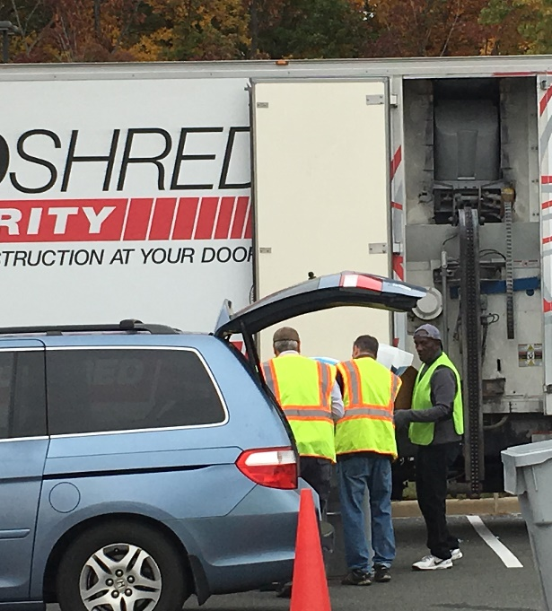
Mega Paper Shred at Pfitzner Stadium
Free confidential document shred, Saturday, October 23
Prince William, VA, September 1, 2021 – The Prince William County Solid Waste Division will hold a free document shred event for Prince William area residents on Saturday, Oct. 23, 8 a.m. to 12 noon (or until trucks reach capacity). The mega shred will be held at Pfitzner Stadium, 7 County Complex Court, Woodbridge, the former home of the Potomac Nationals baseball team.
This event is for residents. Only confidential documents such as bank statements and tax returns will be accepted. Non confidential documents such as junk mail should be recycled at the curb or a Solid Waste facility customer convenience center recycling drop-off. Paper clips (regular size) and staples do not have to be removed.
Residents may bring the equivalent of up to four boxes (18”x12”x15”) of paper for shredding at no charge. No business or commercial shredding will be accepted.
COVID 19 Restrictions: Customers must wear a mask and stay in the vehicle. All items for shredding must be place in the rear of the vehicle (trunk, hatchback, or truck bed) before coming to the shred location.
For additional material limits and guidelines see Events at www.pwcva.gov/trashandrecycling.

