FAIRFAX COUNTY USES CRUSHED GLASS IN CONSTRUCTION PROJECT FOR FIRST TIME
Friday, 1 Feb 2019

Public Works / Solid Waste Management

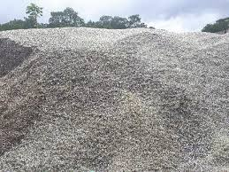
FAIRFAX COUNTY USES CRUSHED GLASS IN CONSTRUCTION PROJECT FOR FIRST TIME
Sanitary sewer replacement projects rarely make headline news. Digging up, repairing, and replacing aging pipes is just part of wastewater infrastructure’s life cycle. It happens all the time, and usually in places well away from public view. But when a project embraces sustainable practices and the idea of a circular economy and finds a constructive use for a waste product, it is worth mentioning.
One example, a project along Flatlick Branch in Fairfax County’s Sully Magisterial District, is currently underway. When the new sewer pipe is placed in the ground, it will rest on a bed of crushed glass instead of the traditional bedding of quarried stone.
THE GLASS PROBLEM
Some people may ask, “Wait, used glass is a waste product? I thought my glass gets recycled?” Unfortunately, the market for recycled glass in our area has been declining for years, and glass is notoriously difficult to process. Read more about how the glass recycling problem is being crushed.

