Glass Recycling Trailer Locations Increased 100%
Monday, 1 Mar 2021

Public Works / Solid Waste Management

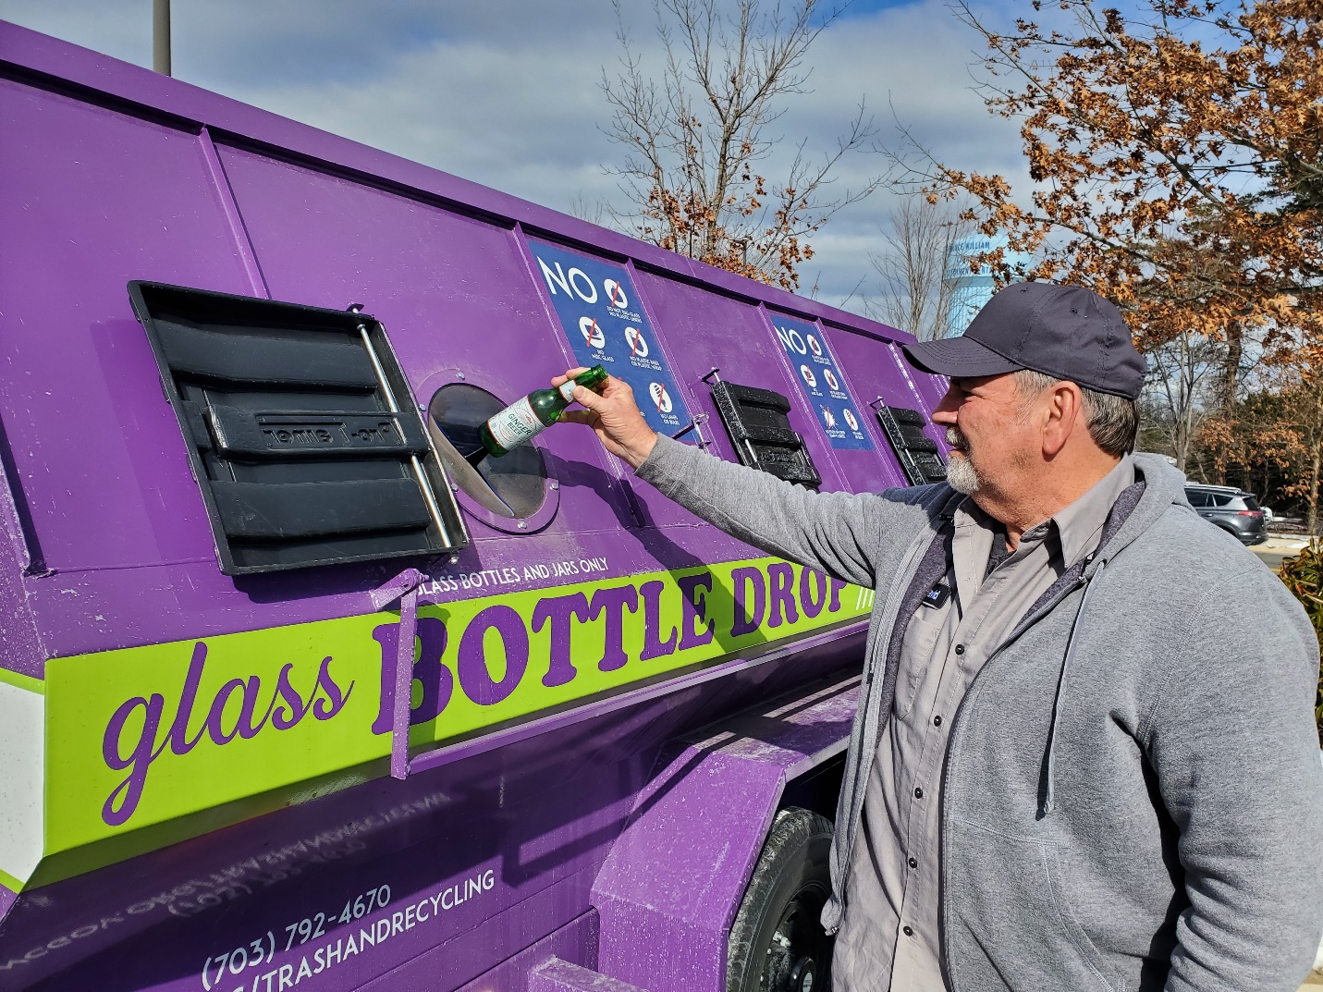
The popular purple bins designated “glass only recycling” have two additional locations. The new glass recycling trailers are now located in the parking lot of the Dr. A.J. Ferlazzo Building in Woodbridge and James S. Long Regional Park in Haymarket. Both are co-located with the county’s blue recycling trailers. Residents can also bring glass bottles, jugs and jars to the Prince William County Landfill or the Balls Ford Road Compost Facility’s purple bins for recycling. Glass placed in these purple recycling bins is sent to special glass processing facilities where the material is used to make new glass containers and other products. Visit the "Other Items" recycling page for more information on glass recycling in Prince William County.

