Compost Awareness Day 2021
Tuesday, 27 Apr 2021

Public Works / Solid Waste Management

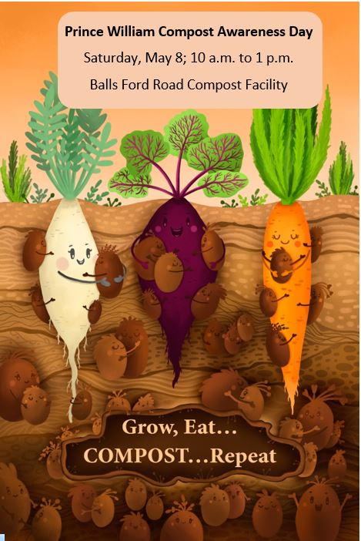
Prince William Compost Awareness Day Promotes Food Recycling
Grow, Eat …COMPOST… Repeat
The Prince William County Solid Waste Division and its partners Virginia Cooperative Extension Prince William Master Gardeners and Freestate Farms will host a Compost Awareness Day event on Saturday, May 8 from 10 a.m. to 1 p.m. The event will be held at the Balls Ford Road Compost Facility, 13000 Balls Ford Road, Manassas. Mask is required.
Volunteers from the Prince William Master Gardeners will be present to share information on composting at home as well as how to use compost in your gardens. In addition, event visitors can drop off food scarps and receive a free compost sample in their own bucket, compliments of Freestate Farms. Compost bins and buckets will also be available for purchase.
This event supports International Compost Awareness Week (ICAW), the largest most comprehensive education initiative of the compost industry. ICAW promotes composting efforts in the back yard and at large scale commercial composting facilities, like the County’s Balls Ford Road Compost Facility, operated by Freestate Farms.
This year’s ICAW 2021 theme is “Grow, Eat …COMPOST… Repeat” to highlight the impact of food recycling and the role humans play in this cycle. The theme promotes the importance of and empowers residents and businesses to compost food and yard waste, as well as use compost to grow healthier food, make healthier soils and, ultimately, create a more sustainable world.
Compost adds carbon back into the soil, promotes erosion control and closes the loop by avoiding the loss of valuable organic resources. From on-farm composting, large-scale commercial composting facilities to community composting and composting in backyards, this amazing resource provides an ecologically responsible option for managing organic materials.
The Balls Ford Road facility conducts commercial scale composting but makes it available to individuals and corporations alike. Beginning October 2021, yard must be collected separately from other trash and recycling. Residents can also bring yard waste—such as leaves brush, garden and hedge trimmings--as well as food scraps to be recycled into compost. The compost that is produced at Balls Ford Road can be purchased by the cubic yard at the Balls Ford facility or the County landfill.
Learn more about the new yard waste collection regulations, composting operations, and other Solid Waste services at www.pwcva.gov/trashandrecycling. Also visit NoVAComposts.com to learn more about composting and its benefits.
Event sponsors include: AshBritt, Broad Run Recycling, ECS-Engineered Compost Systems, Freestate Farms, Loudoun Composting, Mom's Organic Market, Rivas Design & Landscape and Tetra Tech.

